Praise or Panic? Investor Reactions to Corporate Carbon Neutral Pledges
A Senior Thesis
Presented to
The Faculty of the Economics of Department
Bates College
In partial fulfillment of the requirements for the
Degree of Bachelor of Arts
By
Elijah Toffel
Lewiston, Maine
April 17th 2025

Contents
Abstract 3
1 Introduction 4
2 Data 7
2.1 Creation of Sample Data 7
2.2 Carbon Neutral Tracker 8
2.3 Stock and Media Data 9
3 Methods: 11
3.1 Principal Regression: Stock Price Impact 11
3.2 Heterogeneity Analysis: 13
4 Main Results 14
4.1 Impacts on Average Stock Prices 15
4.2 Heterogenous Carbon Pledge Variation on Average Stock Price 16
4.2.1 Carbon Credit Impact 17
4.2.2 Interim Pledge Targets 18
4.2.3 Complete-by Dates 20
4.3 Media Attention 22
5 Conclusion 23
6 Appendix 25
7 References 27

Acknowledgments:
Thank you to my father, Mike Toffel, for showing me what true strength and happiness can look like. Thank you to my mother, Erin Deemer, for showing me how to be brave, care for the wellbeing of those you love, and to persevere through challenges. Thank you to my brother, Isaac, for showing me the value of curiosity, self-motivation, and continuous and steady improvement. Thank you to my college friends, who bring me joy through easy times and hard, and for joining me on this endeavor. Thank you to my oldest friends, for providing everlasting support and appreciating our individualized growth together. Thank you to my advisor, Professor Kyle Coombs, and the rest of my teachers and mentors for your belief in my work, interests, and future.

Abstract
This study examines corporate sustainability promises by analyzing the impact of carbon-neutral pledging on companies’ average yearly stock prices. While previous work has primarily focused on pledges' short-term effect on stock prices (less than 2 weeks), this paper builds upon existing literature by analyzing annual effects, which is a longer time frame. Using a sample of the “most visible” modern companies, carbon-neutral pledging is shown to have a large, though statistically insignificant, negative impact on companies’ stocks in the year that they pledge, followed by a gradual recovery over the following 4 years. This analysis is expanded upon by analyzing three heterogeneous pledge characteristics: carbon credit usage, interim plans, and completion dates. Urgency is found to hurt companies’ stock prices, and pledge information is revealed to be pivotal, as more detailed plans receive reduced negative shocks. Analysis of pledging’s effect on media attention suggests that companies that make carbon-neutral pledges receive fewer negative personal articles but more negative business articles. These stock and media findings are attributed to investors' fear of dramatic changes in company focus, which outweighs the benefits of public praise.

1 Introduction
Selling products to consumers is a multi-layered endeavor that goes beyond promoting a product and has become intertwined with promoting a company, a brand, and a set of ideals. How a product is made, who the company supports, and how the company fits within the greater scope of the world are all important components to consumer decisions. This sentiment is explored in 2024 product branding studies that show that “81% of consumers need to trust a brand to consider buying and 65% of consumers say a brand’s CEO and employees influence their decision to buy” (Howarth 2024). A timely and influential action that has the opportunity to reflect the degree to which companies address consumer concerns is the acknowledgment of company contributions to climate change. Studies have also shown that “55% of consumers are willing to pay more for eco-friendly brands and 84% of customers say that poor environmental practices will alienate them from a brand or company” (Ruiz 2025), suggesting that sustainability may be a worthy investment.
A significant event that sparked demand for corporate eco-responsibility was the 2015 Paris Agreement. This conference resulted in a global target to “substantially reduce global greenhouse gas emissions to hold global temperature increase to well below 2°C above pre-industrial levels and pursue efforts to limit it to 1.5°C above pre-industrial levels” (The Paris Agreement). This brought specific attention to achieving a world-saving sustainability goal by focusing on greenhouse gas emissions and the impact of excess carbon in the atmosphere on global warming. Also in 2015, the UN launched Climate Neutral Now, a project that encouraged companies to commit to achieving a net-zero future by 2050 (Climate Neutral Now). By December 2020, 417 companies from the Forbes 2000 list had pledged net-zero carbon emission targets, which grew to 702 in June 2022, and by June 2023, this collection grew to 923 companies (Net Zero Targets).
Making a carbon-neutral pledge generally requires companies to choose between two options. First, they can reduce their emissions through changes to their company processes, by modifying their production to use less fossil fuels and less energy, or adapting away from other indirect forms of emissions. Second, firms may purchase carbon credits, externalizing the issue, by paying others to complete projects that store or remove carbon from the atmosphere. Most companies use a mix of both strategies.
Theoretically, how shareholder value gets impacted by making and keeping a carbon pledge is ambiguous. On one hand, companies receive public praise for prioritizing adapting their business to benefit the world, which could result in added company value through additional consumers and business opportunities. On the other hand, investors and potential business partners may fear this change, as production efficiency may decrease with the increased focus on sustainable practices. Finding where the scales tip on the value of shareholder praise versus shareholder fear after sustainability pledges are announced is essential to understand how enticing these pledges are for companies to make, and to provide predictive information to interested shareholders.
Additionally, the varying contents of carbon pledges hold value that could tip these scales. Companies that provide more detailed plans or look to hold themselves accountable will be taken more seriously, which again has the potential to earn more praise or scare investors into thinking that profits will be taken less as a priority. The urgency to complete these pledges also holds significance, as companies that aim to complete their pledge within a shorter timeline may be more focused on changing their processes, again fostering the same dilemma of reception. This aforementioned dynamic between shareholder excitement and fear leads to the research question for this paper: How are the stock prices of companies that make carbon-neutral pledges affected post-pledge, and how does this vary based on the company's commitment to use carbon credits, having an interim plan, and differing completion dates?
I hypothesize that making carbon-neutral promises has a positive effect on future earnings. Additionally, I expect companies that pledge to use carbon credits will experience less favorable stock price increases than those that do not. Lastly, those with interim and more urgent plans will likely experience a more positive reception, leading to stock price increases.
This research question has been explored by previous literature, however, primarily on short-term outcomes. On the day of the promise, stock prices of the announcing companies have been found to rise compared to non-pledging companies (Baur 2024). However, beyond just the daily change, Xie et al. analyze the effect of carbon pledges from a 3-day to a 13-day window and find that the average daily abnormal returns were generally negative but not statistically significant. They also discovered that cumulative abnormal returns were statistically significant and negative within the studied periods (Xie 2023). These results mean that daily market reactions to pledged companies were slightly negative and insignificant compared to the rest of the market during these windows; however, the negative effects added up over time to create significant cumulative negative differences. Therefore, pledging companies were found to experience negative stock returns in a short-term period.
My analysis builds upon this literature by analyzing the yearly effects of carbon pledging on stock price. Because this is a relatively new phenomenon, work on the general effect of carbon pledging on yearly stock prices has yet to be published. I further differentiate from existing literature by analyzing pledge content heterogeneity. As an additional experiment, I briefly touch on media attention trends after making a carbon pledge.

2 Data
With undergraduate stock price data limitations, it was essential to find a manageable sample size representing the impact of companies making promises that would affect their public image. To get a complete dataset, I used four sources of data: the first to obtain a sample of visible companies, the second to create a treatment group and explore heterogeneous characteristics, and the third and fourth to obtain outcome variable data.

2.1 Creation of Sample Data
The first dataset used for analysis is scraped reputation data from the Axios Harris Poll 100. From 2019 to 2024, this poll compiles the yearly top 100 “most visible” companies and ranks them by their perceived reputation. The most recent survey (2024) used 16,500 Americans from a nationally representative sample and surveyed them from March 6th to 18th, 2024. The participants were asked to name four companies, two with the highest reputation and two with the lowest. These results were compiled into a list of the top 100 nominated companies, which were then rated by reputation score by a separate group of respondents (Axios 2024). This produced 178 companies listed at least once from 2019 to 2024.
For this paper, the sample was subset to companies that appeared on the poll more than once, to avoid fluke years in visibility. For companies that had parent companies, the latter were used for analysis. This smaller group consisted of 116 subsetted companies.

2.2 Carbon Neutral Tracker
The Carbon Neutral Tracker data contains various carbon-neutral tracking variables for 4,168 companies. Of the 116 companies from the sample data set, Carbon Neutral Tracker contains 98. The main variables of interest were ‘End Year’, which shows the type of sustainability commitments, ‘Carbon Credits,’ and ‘Interim Target.’ The dates of the first carbon-neutral pledge and completion date were scraped from sustainability reports and news articles. One company was dropped (Subaru) due to unclear carbon pledge dates, leaving the sample at 97 companies. Companies that were listed as “Net zero”, “Carbon neutral(ity)”, “Zero Emissions”, “Climate Neutral”, or “Zero Emissions” were listed as treatment. Those listed as “Emissions reduction target” or “No Target” were listed as controls. Emission reductions were differentiated from the rest of the sustainability commitments above because these companies were not a part of the trend to pledge carbon-neutrality by at least 2050. Table 1 shows the distribution of types of commitments.
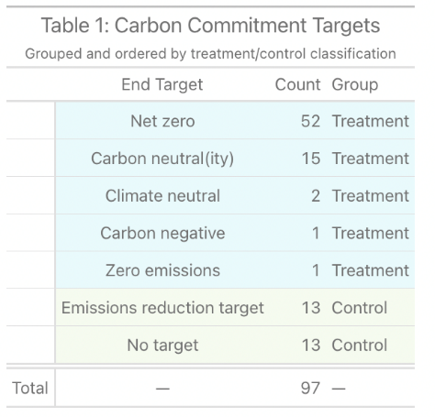

2.3 Stock and Media Data
82 of the sustainability sample's “most visible” companies were public, a characteristic necessary for NYSE stock prices. Average stock data from 2018 to 2024 was collected using the site Macrotrends. Table 2 shows the effect of subsetting to just public companies on the treatment and control groups. Table 3 shows summary statistics on the distribution of carbon pledge characteristics for the treated public companies.
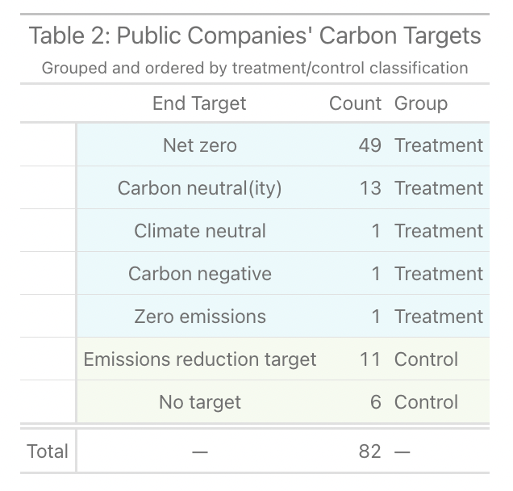
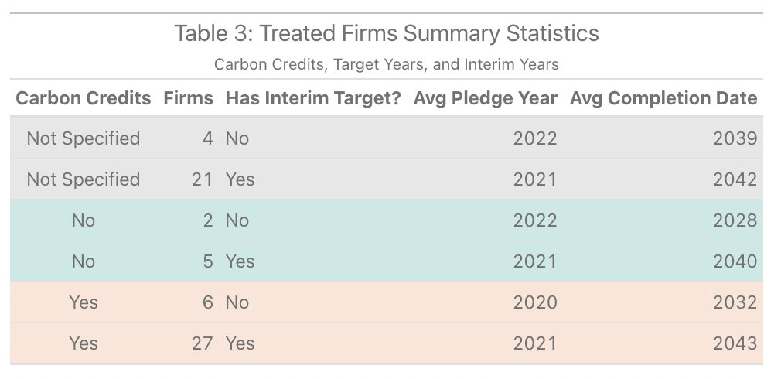
All 97 companies were analyzed for media analysis. For each company, the company name (or a specific name for companies like Progressive Insurance) was searched in Nexis Uni to produce the total number of news articles, negative business articles, and negative personal articles. This data was collected from 2018 to 2024, and negative business and personal articles were calculated as percentages of total articles.

3 Methods:
To analyze the effect of corporate carbon neutrality on stock price, I use a difference-in-difference design to differentiate the impact of carbon neutrality from emission reductions or having no sustainability target.

3.1 Principal Regression: Stock Price Impact
My main result looks at the impact of carbon pledging on companies’ average yearly stock price. This regression uses stock data from public companies from 2018 to 2025. This regression is a staggered difference-in-difference model that compares the effect of companies making a neutrality commitment in year t to companies that have either not made a neutral pledge yet or will never make a neutral pledge, on measures of financial gain. Because we have panel data on yearly revenue and stock prices, individual and time fixed effects are added to the model. This can be shown as:
$$AvgYrStock_{it}=B_{0}+B_{1}Pledged_{i}×PostPledge_{t}+B_{2}Pledged_{i}+B_{3}PostPledge_{t}$$
$$+ a_{i}+γ_{t}+u_{it}$$
In this regression,
- $AvgYrStock_{it}$ is the outcome variable, average yearly stock price, in year t for company i.
- $Pledged_{i}×PostPledge_{t}$ is our explanatory variable of interest. This represents companies that made a carbon-neutral pledge in the years after their pledge.
- $Pledged_{i}$ is a binary variable equal to 1 if company i has made a carbon-neutral pledge.
- $PostPledge_{t}$ is a binary variable equal to 1 if the year is after the company's carbon pledge year.
- $a_{i}$ are company fixed effects.
- $γ_{t}$ are year fixed effects.
- $u_{it}$ is the error term.
While other literature has looked at the daily and weekly effects of stock price, this study can analyze trends that last up to 4 years post-pledge. This regression is labeled as a staggered difference in difference design because companies make pledges in different years, requiring multiple intervention years, instead of just one, as the traditional difference in difference requires. This regression is further specified as a stacked difference in difference design, as treated companies in year t are compared to both untreated companies in year t and treated companies that have not yet been treated by year t.
I expect a positive relationship between making a carbon-neutral pledge and average stock data. Companies will likely gain financially from public attention and support for their mission.
Multiple assumptions must be made for this regression to show the causal effect of carbon-neutral pledging on stock price. These include assuming:
- No other firm characteristics, firm-specific shocks, or time-specific events like a green wave, make the effect of treatment on stock prices different.
- The control group works as a correct estimate of a counterfactual.
- Companies that make carbon-neutral pledges do not benefit financially from public knowledge of the eventual pledge before pledging.
Concerns from these assumptions are substantial, but this model attempts to account for them. First, company and time fixed effects account for time-invariant firm characteristics and consistent time variations. Therefore, fixed effects will account for examples such as specific industries’ stock prices being affected more by carbon-neutral pledging or periods such as green waves that value pledging more effectively. Next, while the control group of untreated public companies is small, the stacked difference in difference design adds more controls to each comparison, as pledged companies are compared to companies in the same year that have not yet pledged or will never pledge. This provides more substance to the control group as a representative counterfactual. Lastly, parallel trends must hold to ensure that making the regression a stacked DiD doesn’t bias our results. This would prove that companies that eventually pledge and those that will never pledge act the same pre-pledge. This is important because it reaffirms that those that never pledged will act as a reasonable estimate for a counterfactual, as they will represent what happens if companies never pledged, since their stock prices are affected similarly to treatment companies in the years before pledging. This also allows pre-pledge companies to be justified as controls, because they act similarly to the pure controls.

3.2 Heterogeneity Analysis:
Another important aspect of analyzing the impact of carbon-neutral pledges is looking into the contents of carbon-neutral pledges. This study examines the relationship between specifying carbon credit use, having an interim plan, and varying completion dates on the treatment effect on stock prices. The same staggered difference in difference regressions is run on each carbon credit group: “Not Specified,” “Yes,” and “No,” and the treatment companies within specification are compared to controls that will never pledge and companies in that carbon credit group that have yet to pledge. This continues for those with an interim plan, those without, and those with a completion date earlier than or equal to 2035 and later than 2035. These designs are compared to their respective results to conclude the importance of each component.
I expect companies that do not use carbon credits will experience the most stock price benefits, as they are pledging to dramatically uproot their process, which seems like the more long-term sustainable option. I also imagine that the public will value those with interim plans and nearer completion dates, as these companies will be taking the pledges more seriously, increasing the praise that they get, and increasing demand for their product. Therefore, I imagine that interim plans and urgent completion targets increase the benefits of pledging.

4 Main Results
Carbon pledges, which are company promises to change current or future operations, offer new ground for investors and journalists to decide on their involvement and engagement with the company. Through staggered difference in difference analysis, I find that companies' stock prices lose an average of 28.1 dollars in the first year after making a carbon-neutral pledge, which they steadily gain back over the following years. Additionally, using the same model, companies that make carbon pledges receive an increase in total news articles each preceding year, slight increases in the percentage of negative business articles, and decreases in the percentage of negative personal articles. I expand on these analyses using heterogeneous comparisons that measure the effects of carbon credits, interim pledge targets, and completion dates. Again, as stock information is only publicly available for public companies, I only consider public companies for stock price analysis.

4.1 Impacts on Average Stock Prices
I find that companies that make net-zero or carbon-neutral pledges experience a substantial drop in their stock prices the year of and the year after they make a net-zero or carbon-neutral pledge in comparison to companies that have not made that pledge, countering the general idea of my hypothesis. As can be seen in Table 4 and Figure 1, these rates slowly recover after the pledges have been made. It’s important to recognize that these results compare to “Year–1,” the year before companies make a carbon pledge. While these results are not statistically significant, they encourage the notion that investors are frightened by the announcement of changes that don’t directly maximize output and efficiency. However, as years continue after the pledge, stock prices recover as investors settle into the change and regain faith in the company’s path to success.
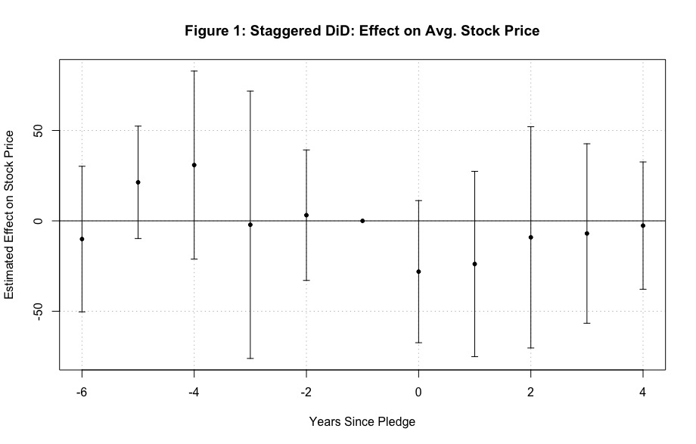
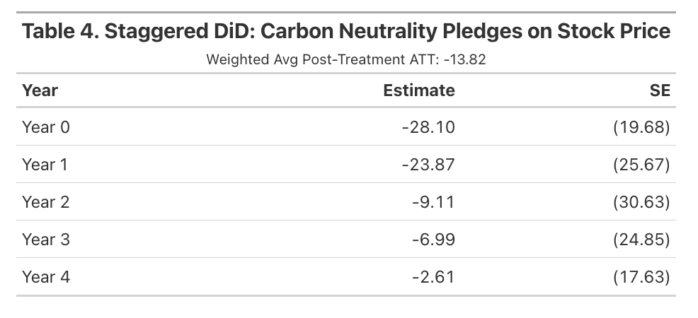
This result counters the hypothesis that carbon-neutral pledges will benefit a company’s valuation in the first couple of years of a pledge. While existing literature hinted that very short-run outcomes would be lower, these negative outcomes continue to exist for longer periods. Investor fears surrounding a lack of economic prioritization seem to overpower the demand increase from public praise regarding company valuation.

4.2 Heterogeneous Carbon Pledge Variation on Average Stock Price
The baseline stock effects suggest companies take on some financial risks by making climate commitments, but this may mask some pledge content heterogeneity. For example, commitments with more urgent completion dates are much more disruptive to business activity than distant commitments, and stock price responses may capture that. I delve deeper into three important elements of a carbon pledge: the use of carbon credits, interim pledge targets, and completion dates. For each of these experiments, I analyze the variables' impact on my staggered DiD result.

4.2.1 Carbon Credit Impact
The first test for variation uses the expressed use of carbon credits within a carbon-neutral pledge. Because the Carbon Pledge Tracking dataset has three categories for this variable, “Yes,” “No,” and “Not Specified,” I compare each category with the same control group from the original staggered DiD. Table 5 and Figure 2 show these three plots.
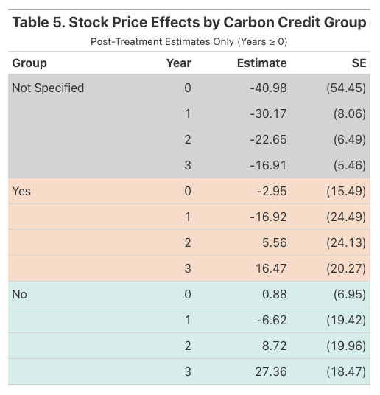
Figure 2: Carbon Credit Heterogeneity
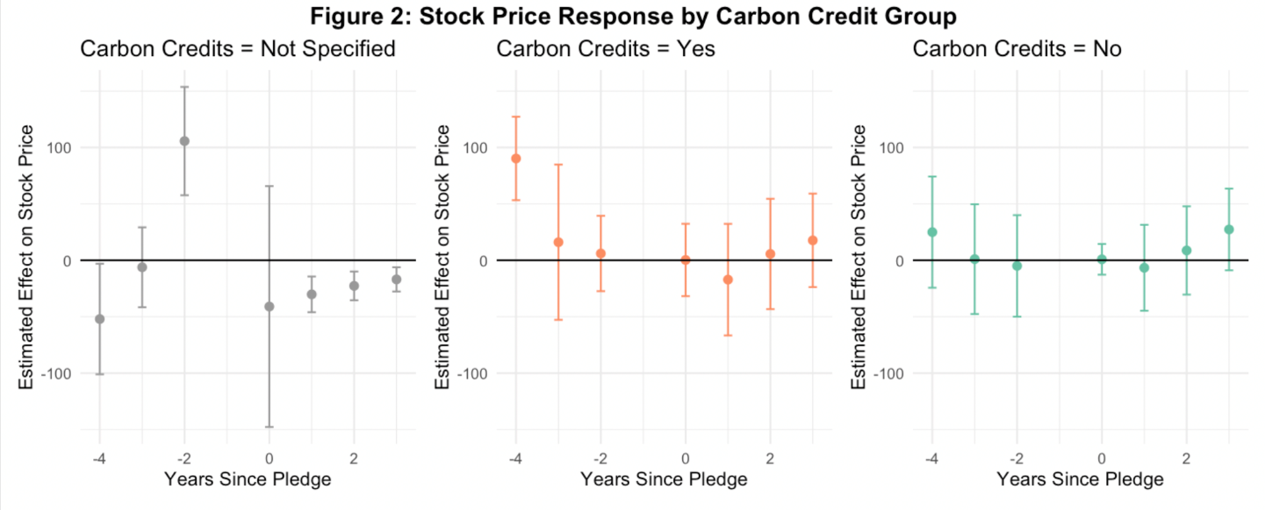
These results suggest that providing carbon credit information minimizes investors' initial shock surrounding carbon pledges. When information on carbon credits is unavailable (“Not Specified”), companies seem to experience a large, yet imprecisely estimated, decrease in stock price in the year of their pledge. However, companies that disclose whether they are using carbon credits do not seem to follow this trend. These results suggest that companies that reveal their carbon credit plans don’t experience the negative shock in the year of their pledges. After a year, all three groups experience a negative shock; however, companies that don’t specify carbon credit use have notably lower stocks the year before the pledge. The preceding years show that companies that disclose their carbon credit plans experience positive effects on stock performance compared to the control groups. In contrast, the unspecified group consistently performs lower than the control group. When looking at point estimates, after 2 years, companies that do not use carbon credits seem to experience a slightly higher stock success than those that use carbon credits, with differences that widen further in year 3. It’s important to understand that these results cannot be deemed causal, as parallel trends do not hold for the “Not Specified” and “Yes” categories, and results are not significant for “Yes” and “No.”

4.2.2 Interim Pledge Targets
This section looks at the effect of companies making an interim pledge within their carbon-neutral pledge. Companies that have made carbon-neutral pledges are differentiated into two groups: “has an interim pledge” and “no interim pledge.” These are each compared to their respective stacked control groups.
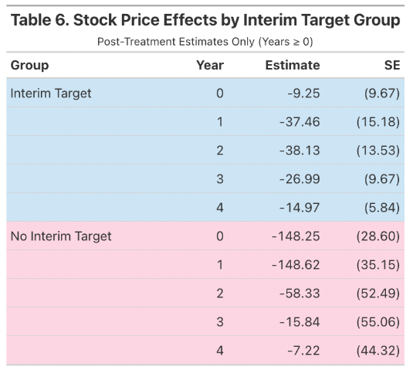
Figure 3: Stock Price Response by Interim Target
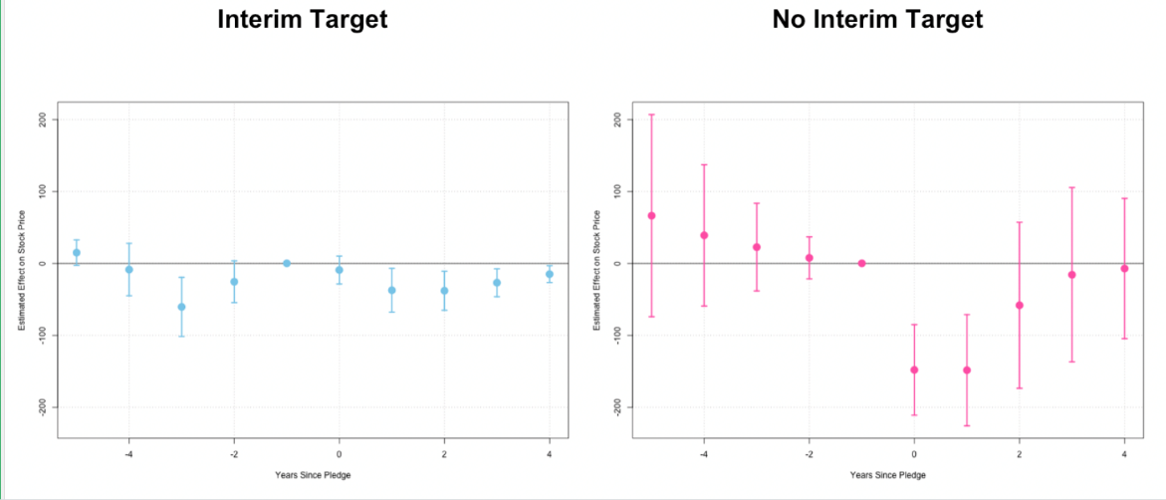
When analyzing Figure 3 and Table 6, we again see that the year of pledge shock to stock price is minimized by more information. When companies reveal an interim plan, they experience a dramatically reduced negative shock. Similarly, to the effect of companies using carbon credits, stock prices dip the year after the pledge for both groups of companies. Companies without an interim target can quickly recover as stock prices return to their pre-pledge rates over time. However, companies with interim targets experience a slower and steadier recovery. This leads to the story that investors may be more immediately scared when companies have no midpoint plan, but over time, they realize that companies with interim plans may be more dedicated to reducing current efficiency to achieve their sustainability goals than those without a plan. It’s important to note that these results show substantial significance, but the number of observations for no interim plan is low.

4.2.3 Completion Dates
The last experiment that this paper investigates is the effects of differing completion dates. When companies make a carbon-neutral pledge, they assign a year to complete it. I test for variation within two groups: those with a completion date earlier than or equal to 2035 and those that plan to complete the pledge later than 2035.
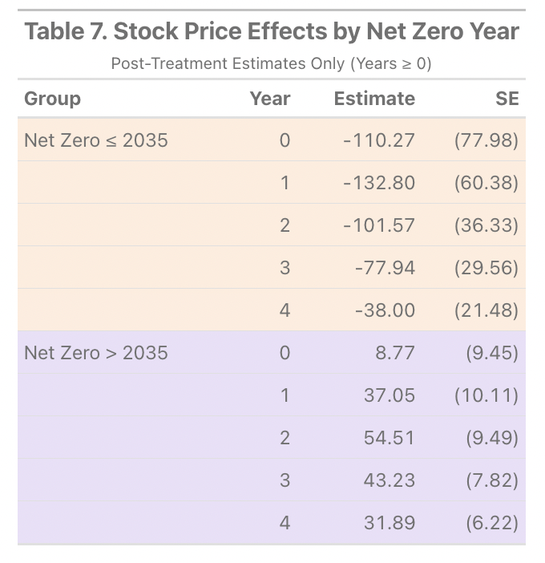
Figure 4: Stock Price Response by Complete-by Date
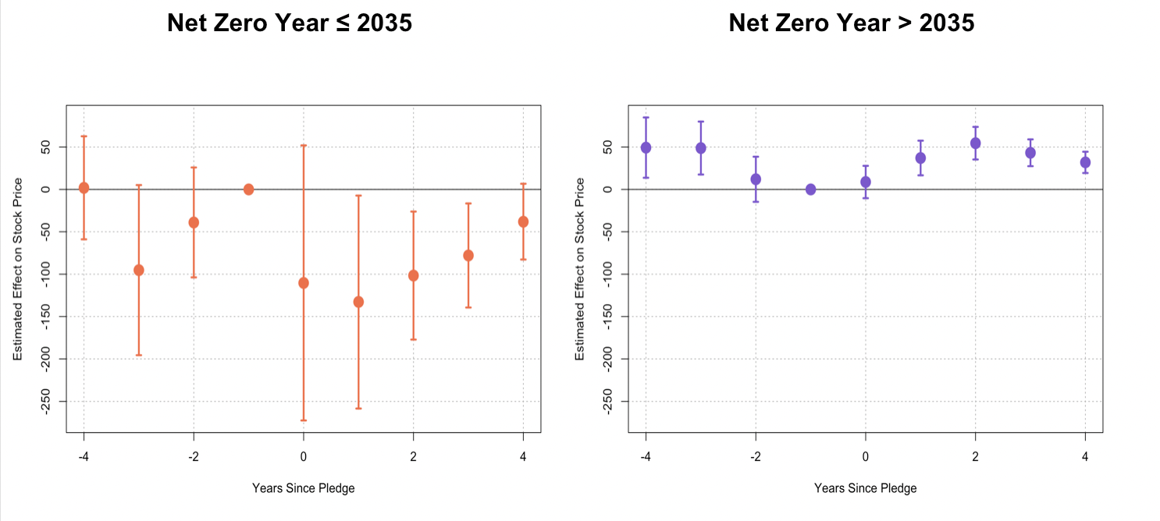
These results show that pledging companies with complete-by dates before 2035 experience a dramatic negative shock in the year of the pledge and the year after. This trend, while the magnitudes are larger, follows similarly to the original trend, where rates slowly and steadily recover. This left-hand graph is the closest we have yet to significant causal results, as parallel trends hold with no statistically significant trends pre-pledge, but post-pledge, there are significant differences between treatment and control.
Companies that pledge to complete later than 2035 have the opposite trends, gaining stock price in the years after the pledge, but slowly descending towards pre-pledge rates in the third year after the pledge. Unfortunately, parallel trends do not hold for this plot.
This variation shows that investors are alarmed when companies make pledges that come with haste to update their methods, but as time goes on, they slowly accept the changes. However, if the pledge date is considerably in the future, investors face less uncertainty about the near future and benefit from the immediate increased attention and boost. But, as that buzz dies down and the pledge years get a bit closer, the stock prices of carbon-neutral pledgers with distant completion dates slowly trend towards pre-pledge rates.

4.3 Media Attention
An important mechanism that illustrates the tipping scale of benefiting or losing financially from carbon pledges is the effect of carbon-neutral pledging on media attention. I look at the impact of companies making a carbon pledge on their total media, the percentage of negative business articles, and the percentage of negative personal articles. I then analyze each outcome variable across the heterogeneous variable, completion date.
Referencing Appendix Figure A1, the results on total media are a bit concerning, as there seems to be a clear trend where companies that had yet to pledge had less total media than the control group, and the point where this changes is at the year before pledging. However, Table A1 does suggest increases in total media after making a carbon-neutral pledge. This could suggest that companies gaining momentum with total media attention are more likely to make a carbon pledge than those that previously had more attention. Consistent with my results surrounding investor panic, negative business articles increase after companies make carbon pledges. However, negative personal articles drop after making a carbon pledge. Increasing percentages of negative business articles could reflect a combination of worries about reducing efficiency and carbon pledging skepticism. The drop-off of negative personal articles could reflect more positive reviews of the CEO’s commitment to public welfare. After analyzing the effect of carbon-neutral pledging on stock prices, these results could suggest that stock prices reflect the types of business articles more than personal articles, especially in the short run.
When testing for heterogeneous characteristics, only one characteristic has meaningful trends: completion dates. Referencing Figure A2, companies that make carbon pledges with completion dates before 2035 receive more total news articles after making a pledge than those with further completion dates. Theoretically, this makes sense as those with nearby deadlines have to change faster, resulting in more headlines on their plans.
Secondly, when looking at the effect of pledging on negative business articles, those that pledge with earlier deadlines have negative trends, while those with later deadlines have positive trends. This could be because later deadlines are under more scrutiny for the reliability of their pledges.
Lastly, personal articles have the opposite effect, where later completion date pledging companies experience fewer negative personal articles than earlier pledgers. This could match the reason for the total articles, where these companies are getting less attention, so there are fewer articles criticizing their CEOs.

5 Conclusion
Carbon-neutral pledges offer the opportunity to improve a company's image, which is important in a politicized, capitalist world. However, these pledges come with accompanying work, which can be costly for companies’ profit maximization strategies. This paper has shown dramatic, yet mostly statistically insignificant, trends that suggest investor panic drops companies' stock price in the year of their pledge. However, in the years after the pledge, stock prices seem to regain strength by slowly returning to their pre-pledge trends. When analyzing heterogeneous pledge characteristics, investor panic seemed to again be at the forefront of trends. When carbon-neutral pledges include more information, like carbon credit information and interim plans, investors panic less in the first year of the pledge. Furthermore, when companies list later completion dates for their pledges, they can receive the benefits of public praise without experiencing investor panic surrounding fears of dramatically uprooting company processes with an urgent deadline. Finally, those who make a carbon pledge seem to receive more total media coverage, higher percentages of negative business articles, and lower percentages of negative personal articles. This reflects the ambiguity of the benefits of praise versus panic, as pledging companies receive more public praise while receiving more business criticism. However, these results support the claim that negative business triumphs over positive praise regarding stock price effects.
This paper contains limitations that can be improved upon in future research. First, due to data limitations, the sample size is fairly small. Specifically, when comparing those that have interim plans to those that do not, the control group is quite small. While a stacked difference in difference design aims to account for small control groups, obtaining a more accurate control group that has no involvement with carbon neutrality could produce more significant results. Furthermore, this paper obtains a sample from a collection of only the most positively and negatively received companies from a random sample, in hopes of creating a sample of the most “visible companies.” This restricts our results from being representative of all companies. One way to improve this sample is by matching companies with similar characteristics, where one makes a carbon pledge and another does not. This could work as an improved model to extract the specific effect of making a carbon-neutral pledge. This paper’s model uses company fixed effects to account for company variation; however, with a small sample size, this paper’s methods can leave variation unaccounted for. Matching companies would provide ideal counterfactuals to compare to treated companies. Lastly, the limited time frame of this study is a limitation. Due to this trend's recency, this paper cannot make long-term claims. Results suggest that stock prices climb back to around pre-pledge trends after 4 years. However, it is uncertain how these trends will continue to change, prohibiting long-term impact implications.
For future analysis, further understanding the effect of media attention on stock price would be interesting. Is it standard that negative personal articles do not have much impact on stock price, and does this change with the heterogeneous characteristics of the companies being written about? Additionally, I would like to look into the effect of keeping or disregarding company pledges on stock prices and investigate how the perception of carbon credit usage changes over time. Lastly, I would like to complement this research by analyzing how company reputation is impacted by making a carbon pledge, and understanding to what degree increased reputation improves or decreases stock prices.

6 Appendix
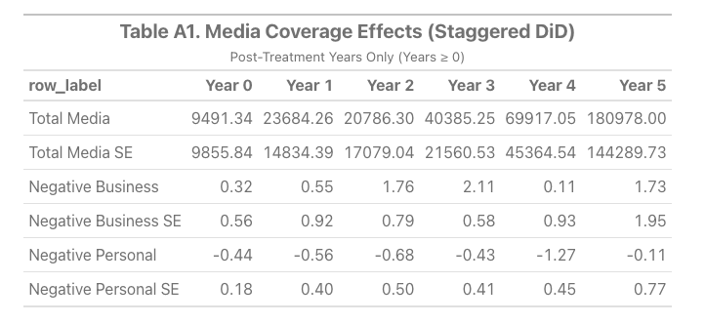
Figure A1: Media Coverage Staggered DiD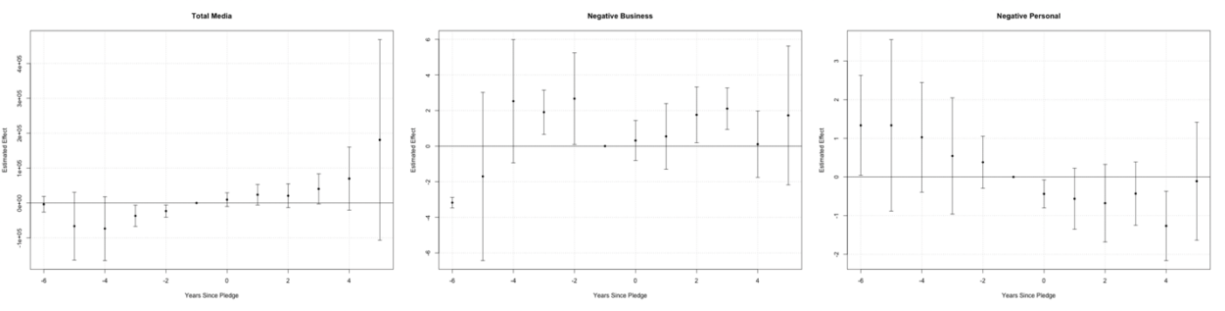
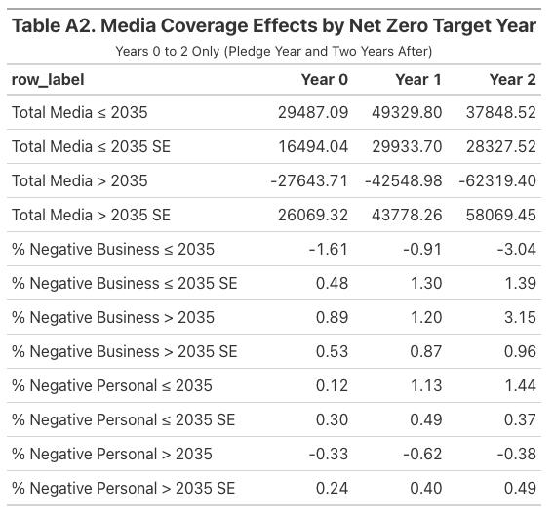
Figure A2: Media Coverage for Completion Date Heterogeniety
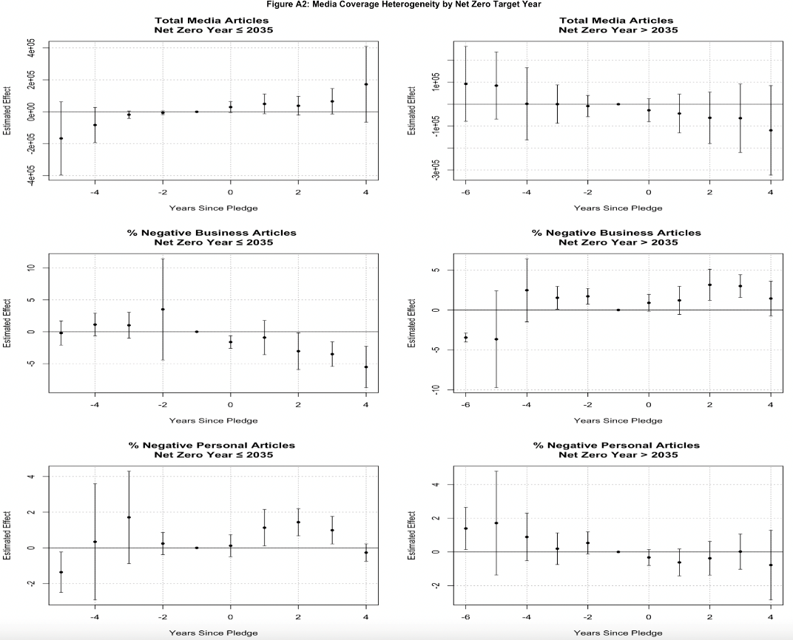

7 Bibliography
Bauer, Michael, Daniel Huber, Eric Offner, Marlene Renkel, and Ole Wilms. "Corporate Green Pledges." December 2, 2024.
"Climate Neutral Now." Unfccc.int. Accessed April 17, 2025. https://unfccc.int/climate-action/climate-neutral-now.
Howarth, Josh. “33 New Branding Statistics and Trends for 2024.” Exploding Topics, May 15, 2024. https://explodingtopics.com/blog/branding-stats.
John Lang, Camilla Hyslop, Diego Manya, Sybrig Smit, Peter Chalkley, John Bervin Galang, Frances Green, Thomas Hale, Frederic Hans, Nick Hay, Angel Hsu, Takeshi Kuramochi, Steve Smith. Net Zero Tracker. Energy and Climate Intelligence Unit, Data-Driven EnviroLab, NewClimate Institute, Oxford Net Zero. 2024.
"Net Zero Targets among World’s Largest Companies Double, But..." Net Zero Tracker, June 12, 2023. https://zerotracker.net/insights/net-zero-targets-among-worlds-largest-companies-double-but-credibility-gaps-undermine-progress.
The 2020 Axios Harris Poll 100 reputation rankings, July 30, 2020. https://www.axios.com/2020/07/30/axios-harris-poll-corporate-reputations-2020.
The 2021 Axios Harris Poll 100 reputation rankings, May 13, 2021. https://www.axios.com/2021/05/13/the-2021-axios-harris-poll-100-reputation-rankings.
The 2022 Axios Harris Poll 100 reputation rankings, May 24, 2022. https://www.axios.com/2022/05/24/2022-axios-harris-poll-100-rankings.
The 2023 Axios Harris Poll 100 reputation rankings, May 23, 2023. https://www.axios.com/2023/05/23/corporate-brands-reputation-america.
The 2024 Axios Harris Poll 100 reputation rankings, May 22, 2024. https://www.axios.com/2024/05/22/axios-harris-poll-company-reputation-ranking-data-source.
The Axios Harris 100 poll of corporate reputations, March 6, 2019. https://www.axios.com/2019/03/06/axios-harris-poll-corporate-reputations.
The Long Term Perspective on Markets. Macrotrends. Accessed April 17, 2025. https://macrotrends.net/.
The Paris Agreement. United Nations. Accessed April 17, 2025. https://www.un.org/en/climatechange/paris-agreement.
Ruiz, Arabella. “52 Huge Environmentally Conscious Consumer Statistics 2025.” TheRoundup, January 26, 2025. https://theroundup.org/environmentally-conscious-consumer-statistics/.
Xie, Xinyi, Jianan Lu, Mao Li, and Jiang Dai. 2023. “Does Carbon Neutrality Commitment Enhance Firm Value?” Journal of Chinese Economic and Business Studies 21 (1): 49–83. doi:10.1080/14765284.2022.2161171.

